LOOKING AND SOUNDING GOOD
Before a first meeting it is good to connect for a test session and make sure your webcam, mic and speakers are working. This can be done with QUB or a work colleague.
Using headphones, a microphone and a PC/laptop all improve sound quality.
Using a mobile phone to join a session may cause some sound interference.
Ask participants to mute their microphones when not in use to improve audio. They can do this by clicking the mute icon at the bottom left side of their screen. Sometimes the meeting host will have muted all the participants and you cannot unmute yourself.
Video quality is affected by the bandwidth available, and can be improved, where appropriate, by asking students to turn off their video. It is important that everyone can see you so please make sure you are in view of the camera.
GETTING OFF TO A GOOD START - Welcome slide on screen as students enter meeting
- Session title
- Learning outcomes
- Outline of session
- Etiquette reminders
- Encourage use of chat
WHAT DO STUDENTS LIKE? - No different to what makes any teaching session successful
- Use of positive language and encouragement
- Tutor was very welcoming
- Clear structure
- Upbeat, smiling, tutor moves and gesticulates
- Lots of Interaction
WHAT DO STUDENTS DISLIKE?
- Starting session without orientation (welcome, outline structure, engage with everyone)
- Ending session abruptly (invite chat / questions to clarify before drawing to close)
- Not checking sound/IT quality
- Few opportunities for interaction provided
- Little eye contact
- Monotonous tone of voice
- Tutor doesn’t move

PRACTICAL TIPS DURING THE ZOOM SESSION
Allow time to welcome everyone. Early interaction with ALL students encourages ongoing interaction from everyone throughout the session and helps set an expectation for their contribution. Encourage interactions every 5-10mins to maintain attention and engagement.
- Brief chat with each student in turn – also serves as a sound check
- Seek feedback early (on any topic) by encouraging to use the chat box
- Ask a question to the group, ask everyone to enter their response in chat but hold sending until teacher asks. Everyone responds simultaneously and teacher can refer to 1-2 comments. Known as a “chat bomb”
- Encourage questions, either verbally or using chat
- Allocate tasks to certain students within the session

Gallery View

Basically, gallery view is a cluster of participants screens.
It’s a nice way to display participants, allowing students to see each other.
Anyone can change the view of content/participants on their screens.
If a two-monitor set up is possible, content can be on one screen so information can be seen properly.
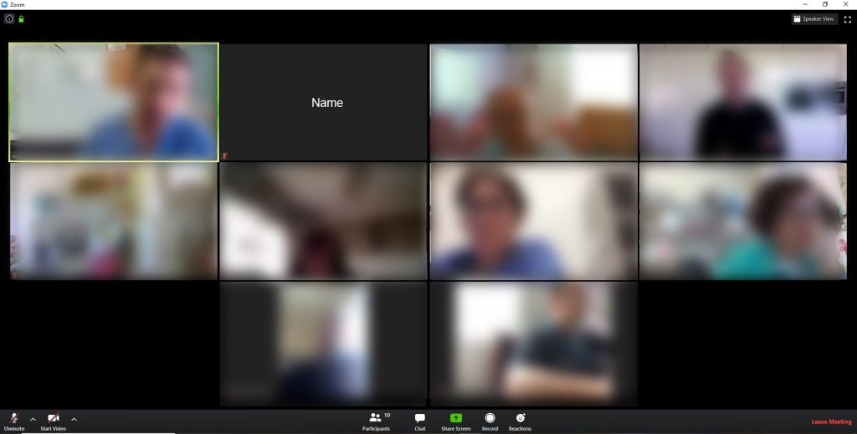
Zoom – Gallery view

